

**ASSIGNMENT**

**NAME- ANVESHNA**

**COURSE- BTECH CSE CORE**

**SECTION- A**

**ROLL NO. - 2501010130**

**INTRODUCTION-**

This project is a CLI based calorie tracker which enables uses to get his/her average calories per meal, total calories consumes and also prints a summary table consisting all the meals and their calories. The project shows the practical use of Python concepts like input/output operations, data storage using lists, arithmetic and comparison operators, conditional statements and loops. Also , this program has Exceed Limit Warning System .

**ASSIGNMENT TASKS**

**Task 1: Setup & Introduction**

* Create a project folder daily_calorie_tracker

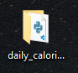

* Inside the folder, create a starter Python script tracker.py

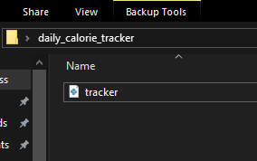

* Add a comment header with your name, date, and project title.

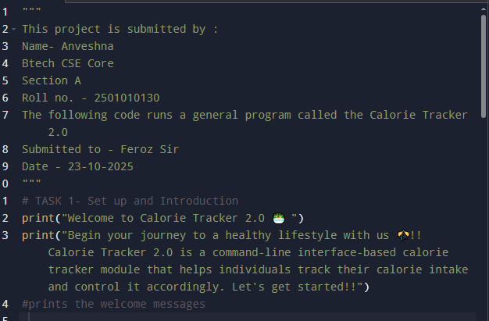

* Print a welcome message describing what the tool does.

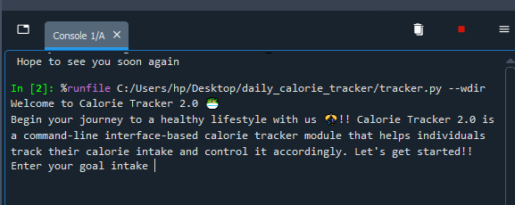

**Task 2: Input & Data Collection**

* Use input() to accept: o Meal name (e.g., “Breakfast”) o Calorie amount (e.g., “350”) — convert it to int or float

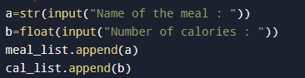

* Store the meal names in one list and calorie amounts in another list.

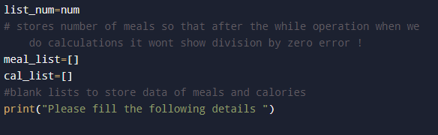

* Ask the user how many meals they want to enter (loop accordingly).

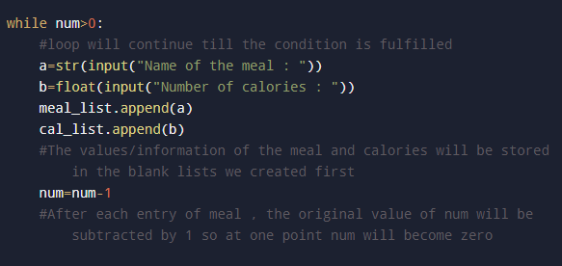

**Task 3: Calorie Calculations**

Use sum() to calculate total calorie intake.

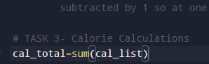

Compute average calorie per meal.



Ask user to input their daily calorie limit and compare it to total.

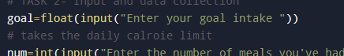

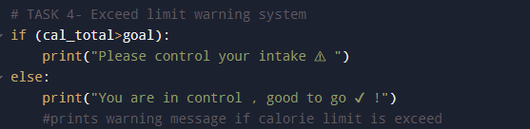

**Task 4:**

Exceed Limit Warning System

Use if...else or if statements with comparison operators:

If calorie intake > daily limit → show a warning message.

Else → show a success/within-limit message.



**Task 5: Neatly Formatted Output**

Print a summary table with the following using f-strings :

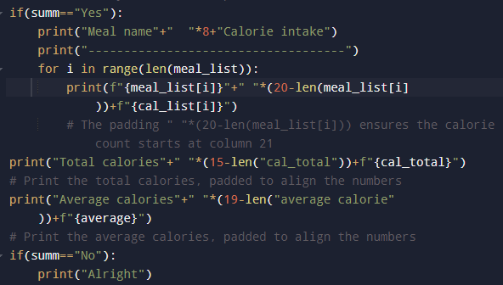



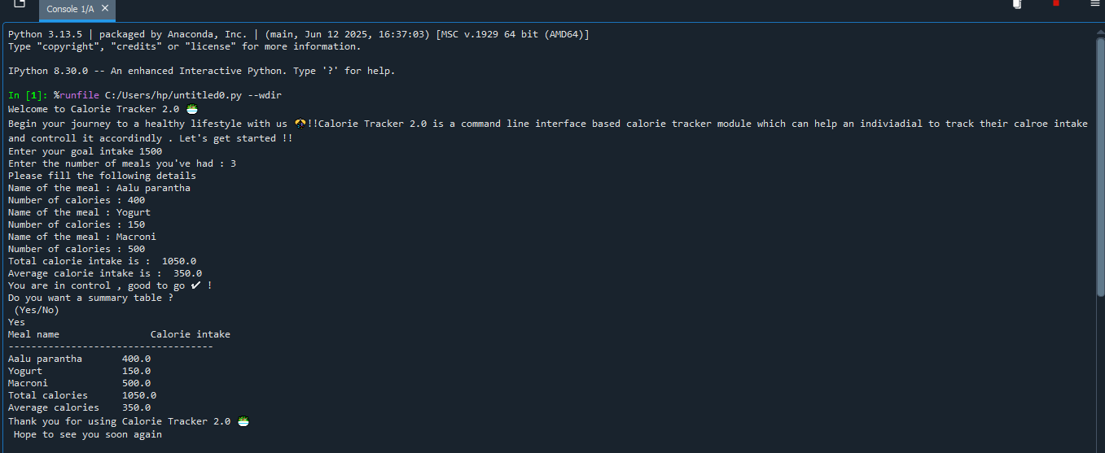**OUTPUT 1**

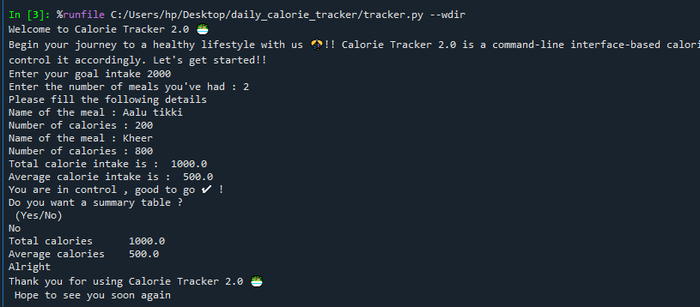**OUTPUT 2**

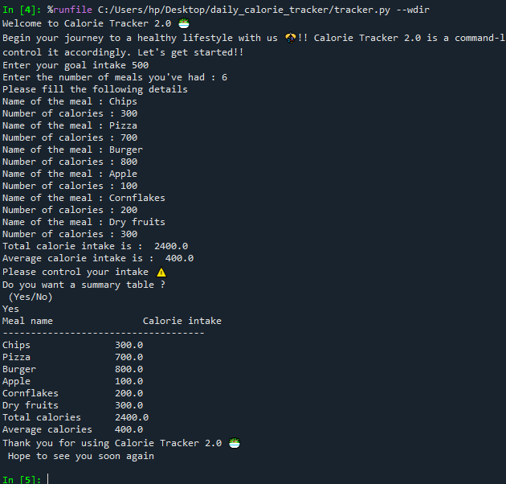**OUTPUT 3**